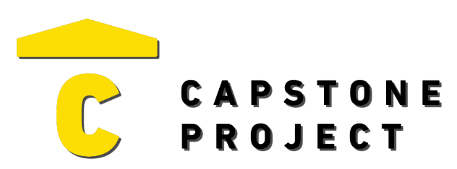
USER FEEDBACK
User Name: William Skinner
What are your thoughts on the project overall?
The project is complex but has its issuses.

Was the project enjoyable? What was your favorite part of the project?
The best part of this is the usability.
What changes would improve the project?
More time for better analysis

Capstone Project Ratings:
Project Technology Depth (shows good usage of technology) | High
Project Breadth (number of features and content) | Medium
Professional Presentation (analogous to a real-world product) | High
Implementation Quality (number of bugs and errors) | Medium
Project Completeness (project contains essential functionality) | High

Game / Application / Website Ratings:
Visuals (art style, environment, effects) | Mixed
Audio (sound effects, music) | Mixed
UI (title, menus, UI elements, text) | Positive
Controls (intuitive, ease of use, ease of navigation) | Very Positive
Interactivity (fun, engagement, flow) | Positive

